**EXPERIMENT-4**

**DESIGN ANIMATION USING GIMP**

**Step – 1:** Download and gather all the images required in order to create a GIF.

**Step – 2:** Open GIMP in your computer. Go to File -> Select Open as layers

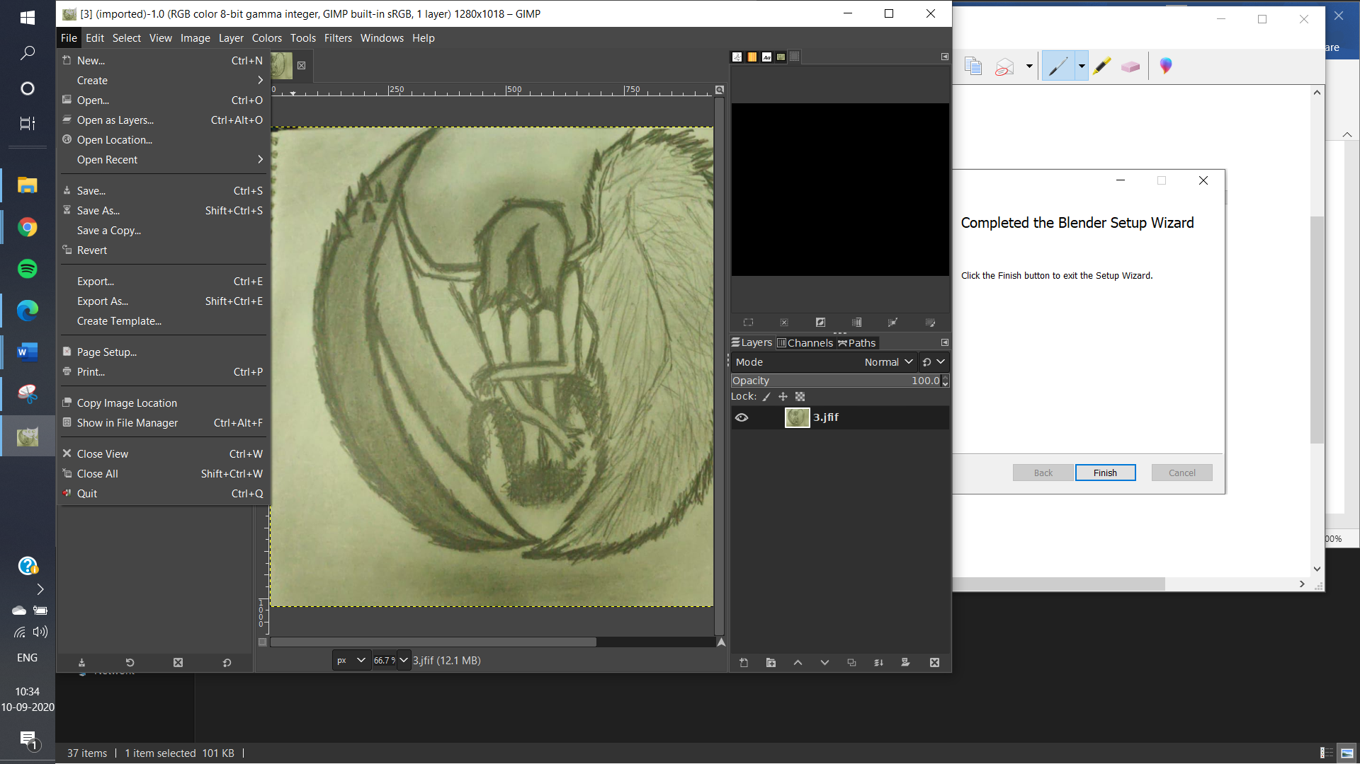

**Step – 3:** Go to the respective folder and open all the images in a certain order, i.e., from the first image till the last image.

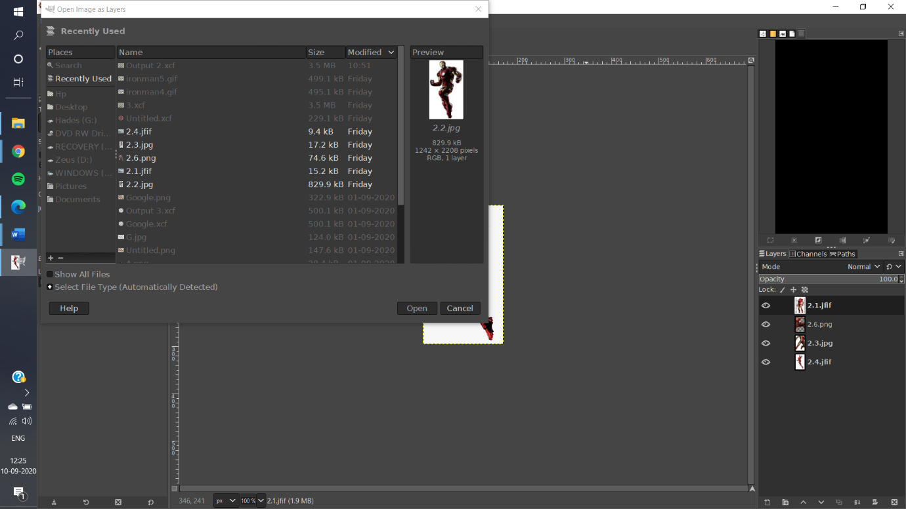

**Step – 4:** All the selected images are now opened in the layers section. Reorder the layers by their sequence number using the arrow.

**Step – 5:** Go to File -> Select Export as -> Rename the filename with extension **.gif** and click on Export.

**Step – 6:** A dialog box opens up. Click As animation under GIF Options. Under Animation GIF options, select the time accordingly, say 100 seconds. Also, check Use delay entered above for all the frames. Click on Export.

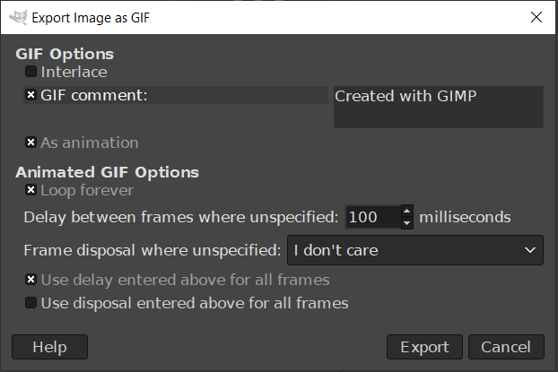

**Step – 7:** The animation is saved with extension .gif in the specified folder.

